Movie Reviews and Ratings

Software Development Plan

Version <1.1>

Revision History

| **Date** | **Version** | **Description** | **Author** |
| --- | --- | --- | --- |
| 22/10/2021 | 1.0 | Complete 4.2: Project plan | Hoang Huu Giap |
| 23/10/2021 | 1.0 | Complete Gantt Chart | Hoang Huu Giap |
| 23/10/2021 | 1.0 | Complete 1. Introduction and 2. Project Overview | Ngo Truong Tuyen |
| 24/10/2021 | 1.0 | Complete 4.3: Project Monitoring and Control | Nguyen Tan Viet |
| 24/10/2021 | 1.0 | Complete 3: Project Organization | Bui Huynh Trung Nam |
| 10/11/2021 | 1.1 | * Update 2.1 (programming language and main feature of our website) * Update 4.2.1: Phase and Iteration Plan * Update 4.3.2: Risk management | Hoang Huu Giap |
| 13/11/2021 | 1.1 | Update 4.3.3 Configuration management | Bui Huynh Trung Nam |

Table of Contents

**1. Introduction** **4**

1.1 Purpose 4

1.2 Scope 4

1.3 Definitions, Acronyms and Abbreviations 4

1.4 References 4

1.5 Overview 4

**2. Project Overview** **4**

2.1 Project Purpose, Scope, and Objectives 4

2.2 Assumptions and Constraints 5

2.3 Project Deliverables 5

**3. Project Organization** **5**

3.1 Organizational Structure 5

3.2 Roles and Responsibilities 6

**4. Management Process** **10**

4.1 Project Estimates 10

4.2 Project Plan 10

4.2.1 Phase and Iteration Plan 10

4.2.2 Releases 13

4.2.3 Project Schedule 13

4.3 Project Monitoring and Control 13

4.3.1 Reporting 13

4.3.2 Risk Management 13

4.3.3 Configuration Management 13

Software Development Plan

# 

# 1. Introduction

## 1.1 Purpose

The purpose of the *Software Development Plan* is to gather all information necessary to control the project. It describes the approach to the development of the software and is the top-level plan generated and used by managers to direct the development effort.

The following people use the *Software Development Plan*:

* The **project manager** uses it to plan the project schedule and resource needs, and to track progress against the schedule.
* **Project team members** use it to understand what they need to do, when they need to do it, and what other activities they are dependent upon.

## 1.2 Scope

This *Software Development Plan* describes the overall plan to be used by the Movie Reviews and Ratings project, including deployment of the product. The details of the individual iterations will be described in the *Iteration Plans*.

The plans as outlined in this document are based upon the product requirements as defined in the *Vision Document*.

## 1.3 Definitions, Acronyms and Abbreviations

None.

## 1.4 References

Instruction video for this document (Mr. Ho Tuan Thanh): [Link](https://www.youtube.com/watch?v=FS125VoBlro&list=PL3Bp9JDvkAra8rRrUPOpfKdKvJ6-okqaw&index=10)

Document reference: [Link](https://sce.uhcl.edu/helm/RationalUnifiedProcess/examples/csports/ex_sdp.htm)

## 1.5 Overview

* This Software Development Plan contains the following information:
* Project Overview - provides a description of the project's purpose, scope, and objectives. It also defines the deliverables that the project is expected to deliver.
* Project Organization - describes the organizational structure of the project team.
* Management Process - explains the estimated cost and schedule, defines the major phases and milestones for the project, and describes how the project will be monitored.

# 2. Project Overview

## 2.1 Project Purpose, Scope, and Objectives

Purpose: Although there are many movie reviews websites in the world, they are almost foreign websites and are not popular in Vietnam. Our website will provide movie reviews and ratings for everyone (focus on Vietnamese).

Scope:

* Target users: People who love movies, want to see reviews, ratings to choose movies which they want to see. Age: 10+
* Environment:
  + Platform: Web.
  + Language: HTML, CSS, JavaScript and maybe PHP.
  + Tools: Text editor (Visual Studio Code or Sublime text), browser (Chrome, Edge)...

Objectives: To become a popular movie review website in Vietnam.

Main features:

* Review movie
* Comment
* Rate a movie review
* Search a movie review
* Login/logout, create account
* View account history
* View user profile
* Like or dislike a review
* Classify film
* Top ranking movie review
* Report to admin about bugs, spam comments…
* ...

## 2.2 Assumptions and Constraints

| Budget | 0 USD |
| --- | --- |
| Staff salaries | 0 USD |
| Staff | 5 people of team |
| Schedule | 12 weeks |
| Equipment | All laptops, smartphones of team members |

## 2.3 Project Deliverables

Deliverables for each project phase are identified in the *Development Case*. Deliverables are delivered towards the end of the iteration, as specified in section *4.2.3 Project Schedule*.

Output of project: Movie Reviews and Ratings website, accompanying documents.

# 3. Project Organization

## 3.1 Organizational Structure

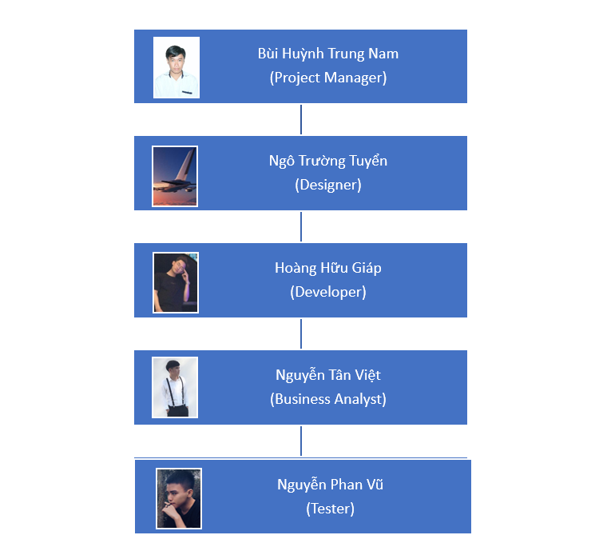

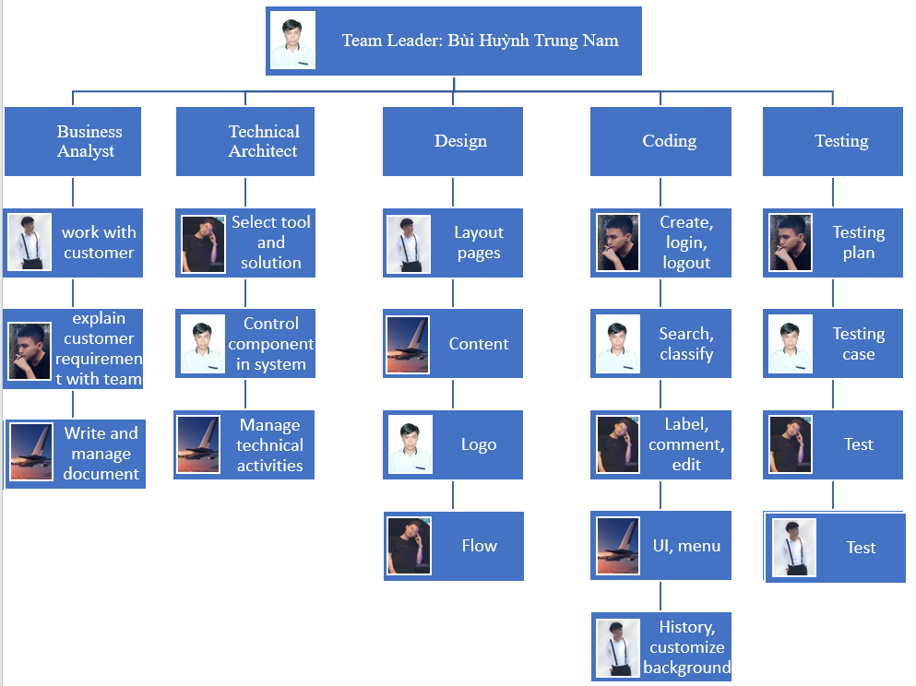

## 3.2 Roles and Responsibilities

| **Person** | **Role** |
| --- | --- |
| Bùi Huỳnh Trung Nam | **1. Leader:**   * Responsibility for the project * Managing document, meeting, plan/weekly/review meeting note * Connect other people together * determine whether project result is good or bad   **2. Main purpose the team will do:**  **2.1 Developer:**   * Make plan * Implementing the code for features of the project according to the task assignments. * Learn from experience through PAs (review for better) * Documents   **2.2 Technical Architect:**   * Make plane * Find and select tool, solution for each PA and all project * Determine component system and main role of them to improvement * Manage activities of each member to make sure the team does the right things (related to the requirements of project or customer) * Update technology and technique frequently * Documents   **2.3 Design:**   * Make plan * Create abstract runflow for project * Create layout of each page * Create features inside each page (content, function,...) * Documents   **2.4 Business Analyst :**   * Make plan * Work with customers on requirement of product (or assignment requirements) * Community or explain with other people in team and discuss these problems (overview) * Document   **2.5 Tester:**   * Make plan * Find bugs in working process * Test case * Test analysis and design * Evaluate system   **3. Workflow**  1. Each member will know what to do after planning meeting  2. Person who has a problem/ issue in the working process will present at the weekly meeting and everyone will find solutions together  3. Another problem will be contacting the leader  4. Try to do all things before deadline 2 days  5. At the review meeting, everyone will know the mistakes of each PA and have a solution to enhance  6. Turn back in step 1 after finishing 1 sprint  **4. Participation**  40% in all work of technical architect  10% in all work of technical design  30% of all work is coding  20% all work of testing  Control/ manage project |
| Ngô Trường Tuyển | **Participation**  30% in all work of business analyst  40% in all work of technical architect  40% all work of design  20% all work of coding  Control/ manage github |
| Hoàng Hữu Giáp | **Participation**  20% in all work of technical design  30% all work of design  20% all work of coding  30% all work of testing  Control/ manage slack, Google drive |
| Nguyễn Tân Việt | **Participation**  30% in all work of business analyst  20% in all work of design  10% all work of coding  30% all work of testing  Control/ manage trello |
| Nguyễn Phan Vũ | **Participation**  40% in all work of business analyst  20% in all work of coding  20% all work of testing  Control/ manage/write plan-weekly-review meeting note |

# 4. Management Process

## 4.1 Project Estimates

This project is estimated to be completed in 12 weeks (05/10/2021 - 25/12/2021).

## 4.2 Project Plan

### 4.2.1 Phase and Iteration Plan

The Inception phase of our project will take 2 weeks to do. It can be viewed as follows:

| Task | Start date | End date |
| --- | --- | --- |
| INCEPTION | 17/10/2021 | 30/10/2021 |
| Write the first weekly report | 20/10/2021 | 21/10/2021 |
| Project plan | 22/10/2021 | 24/10/2021 |
| Vision document | 25/10/2021 | 28/10/2021 |
| Write the second weekly report | 29/10/2021 | 30/10/2021 |
| Inception complete | 30/10/2021 | 30/10/2021 |

Our project has 3 phases: Inception, Elaboration and Construction. The phases and the relative timeline is shown in the table below:

| Phase | No. of Iterations | Time estimate | Start date | End date |
| --- | --- | --- | --- | --- |
| Inception Phase | 1 iteration | 2 weeks | 17/10/2021 | 30/10/2021 |
| Elaboration Phase | 2 iterations | 4 weeks | 31/10/2021 | 27/11/2021 |
| Construction Phase | 2 iterations | 4 weeks | 28/11/2021 | 25/12/2021 |

The milestones that mark the end of each phase can be seen in the table below:

| Description | Iteration | Milestone |
| --- | --- | --- |
| Inception Phase | Only one iteration | In this iteration we have 4 meetings in 2 weeks.  In the planning meeting: revised PA0 once more. Take consideration of the comments of TA, and fix it. Read the PA1 requirements and the leader will assign tasks for members.  In this inception phase, we focus on project plans, vision documents and write weekly reports.  In 2 weekly meetings: after all members have read the PA1 requirements and understand and do it. Every member makes a comment on their work last week, and then moves on to next week.  In the review meeting: we revised everything we did and learned from experience.  Also in this iteration, we will decide what language, IDE, and browser to create our website. |
| Elaboration Phase | First iteration | Revised project plan and vision document.  Draw a use-case model. |
| Second iteration | Design document (including UI prototypes, architecture document).  Work on a test plan, use case document with a revised use case model. Analyze the requirements and will develop the architectural prototype.  Complete use-case specification.  Coding front-end and a little bit about databases (Firebase, MongoDB). |
| Construction Phase | First iteration | Revised artifacts submitted in Elaboration. Write source code, complete all functions listed in PA0. |
| Second iteration | Work on test cases, write test reports, weekly reports and final presentations. |

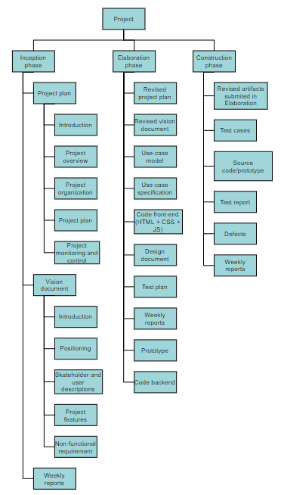

Picture above is our Work Breakdown Structure (WBS)

### 4.2.2 Releases

Our group will have at least 2 products for testing. The first product will be released after we finish the Elaboration phase. The second product will be released after the first Iteration of Construction Phase. During this project, we will release more small products with 1 or more functionalities of our website (unit test).

### 4.2.3 Project Schedule

Project Schedule is presented here: [Group03_Gantt Chart](https://docs.google.com/spreadsheets/u/0/d/17wpWSuy9QJ4TumwDOSJMpxJzwlCjqfe179FHdvnsKOY/edit)

## 4.3 Project Monitoring and Control

### 4.3.1 Reporting

* Weekly meeting
* Weekly status report
* Planning meeting
* Review meeting
* And some other reports like test reports...

### 4.3.2 Risk Management

| No. | Risk | Affect | Probability | Description |
| --- | --- | --- | --- | --- |
| 1 | Website development is new with us | Project and product | Frequently | Our group has to spend more time learning HTML, CSS, and JavaScript. |
| 2 | Firebase realtime database is new with us | Project and product | Likely | This is the first time we use Firebase. We don’t use MongoDB because it's so popular. In order to become acquainted with NoSQL, we spend a lot of time learning. |
| 3 | Lack of creative | Project and product | Likely | We are building this movie review website from zero. So, every member has to think more creatively, and work hard to build a good website. Since we're new we can sometimes hit a dead end. |
| 4 | Some members have some problems with the internet during online meetings. | Project | Occasional | The problem with fiber optic that make some members can’t access Zoom meetings. |
| 5 | Some members get headaches, fever after being vaccinated. | Project | Seldom | After being vaccinated, some members have a bad feeling. |
| 6 | Member turnover. | Project | Unlikely | During the project, some members may leave because of personal reasons. |
| 7 | Some bugs occur during coding. | Project and product | Likely | Bugs are inevitable |
| 8 | Some software we use requires money to activate. | Project | Seldom | There are some software we need to use like: MS Project, StarUML that require us to buy a license. |
| 9 | Member’s abilities aren't suitable | Project and product | Seldom | When the leader assigns tasks to members. There will be some tasks that aren't suitable for them. |

### 4.3.3 Configuration Management

* Google drive: storing and sharing documents, files,..
* Github: storing and managing source codes and related files,..
* MySQL server: application’s database
* Zoom: connect people to have a meeting, discussing
* Some websites support for diagram such as figma